The AirPrime HL7800 module provides advanced and efficient low power modes in addition to 3GPP advanced power saving features like PSM (Power Saving Mode) and eDRX (extended DRX).
The purpose of this document is to provide more detailed description of the AirPrime HL7800 module Low power modes, while it is configured in PSM or eDRX.

AirPrime HL7800 Low Power Modes - Application Note
Contents
References 2
3GPP Power saving features 2
PSM 2
Description 2
CPSMS AT command 3
CEREG AT command 4
eDRX 6
Description 6
+CEDRXS AT command 6
+CEDRXP AT command 7
Example 8
AirPrime HL7800 Low Power modes 10
System description 10
AirPrime HL7800 power modes 11
+KSLEEP AT command 11
Running mode 11
Sleep mode 11
Lite Hibernate mode 11
Hibernate mode 12
Low power mode operation 13
Low Power mode use cases 14
PSM use cases 14
eDRX use cases 17

References
Ref. # | Document title | Doc. #
[R-1] | AirPrime - HL78xx - AT Commands Interface Guide | #41111821
[R-2] | AirPrime - HL7800 - Product Technical Specification | #41111094

3GPP Power saving features

PSM

Description
Power Saving Mode (PSM) is a 3GPP release 12 feature. PSM is very similar to a modem-off state, except that the AirPrime HL7800 module is still registered with the network and may have open EPS session and/or PDN connections. When a host processor needs to send data over the network, it can wake-up the module and sends data without having to reattach and re-establish IP connection. While in PSM mode, the AirPrime HL7800 is reachable only when the module is in connected mode or for a short period of time after this connected mode (Active timer).
The AirPrime HL7800 module can request PSM mode during attach or tracking area update (TAU) procedures. Two timers are requested within PSM mode:
- T3324 called active timer. The T3324 active timer determines the duration during which the AirPrime HL7800 module remains reachable for mobile terminated transaction on transition from connected to idle mode. Upon the active timer expiration, the AirPrime HL7800 module enters Power Saving Mode and may enters in a low power state.
- Extended periodic TAU (T3412 timer). The T3412 (Tracking Area Update timer) is used to periodically notify the availability of the AirPrime HL7800 module to the network. The AirPrime module may request a longer value than the default one assigned by the network using the Extended periodic TAU value. Thanks to this, the AirPrime HL7800 module may stay in PSM state for a very long period of time

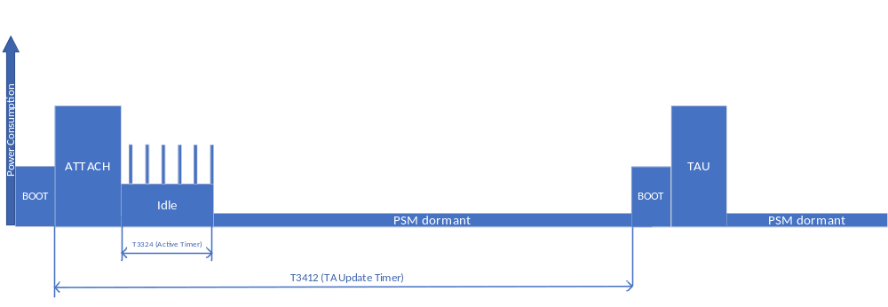
Power Saving Mode – No data (simplified view)

CPSMS AT command
See Document [R-1] for detailed AT command description
Syntax
AT+CPSMS=[<mode>[,<Requested_Periodic-RAU>[,<Requested_GPRS-READY-timer>[,<Requested_Periodic-TAU>[,<Requested_Active-Time>]]]]]
Description
The set command controls the setting of the UEs power saving mode (PSM) parameters. The command controls whether the UE wants to apply PSM or not, as well as the requested extended periodic TAU value in E-UTRAN and the requested Active Time value. See the unsolicited result codes provided by commands +CEREG for the Active Time value and the extended periodic TAU value that are allocated to the UE by the network in E-UTRAN.
Defined values
<mode>: integer type. Indication to disable or enable the use of PSM in the UE.
0 Disable the use of PSM
1 Enable the use of PSM
2 Disable the use of PSM and discard all parameters for PSM or, if available, reset to the manufacturer specific default values.
<Requested_Periodic-RAU>: Not used on AirPrime HL7800 module
<Requested_GPRS-READY-timer>: Not used on AirPrime HL7800 module
<Requested_Periodic-TAU>: Requested extended periodic TAU value (T3412).
<Requested_Active-Time>: Requested Active Time value (T3324)

Extended periodic TAU value is coded as shown below:
Bit
8 | 7 | 6 | 5 | 4 | 3 | 2 | 1
Unit |  |  | Timer value

Bits 5 to 1 represent the binary coded timer value and unit is coded as below:

bit
8 | 7 | 6
0 | 0 | 0 | value is incremented in multiples of 10 minutes
0 | 0 | 1 | value is incremented in multiples of 1 hour
0 | 1 | 0 | value is incremented in multiples of 10 hours
0 | 1 | 1 | value is incremented in multiples of 2 seconds
1 | 0 | 0 | value is incremented in multiples of 30 seconds
1 | 0 | 1 | value is incremented in multiples of 1 minute
1 | 1 | 0 | value is incremented in multiples of 320 hours
1 | 1 | 1 | value indicates that the timer is deactivated

Active Time value is coded as shown below:
Bit
8 | 7 | 6 | 5 | 4 | 3 | 2 | 1
Unit |  |  | Timer value

Bits 5 to 1 represent the binary coded timer value and unit is coded as below:

bit
8 | 7 | 6
0 | 0 | 0 | value is incremented in multiples of 2 seconds
0 | 0 | 1 | value is incremented in multiples of 1 minute
0 | 1 | 0 | value is incremented in multiples of decihours
1 | 1 | 1 | value indicates that the timer is deactivated

CEREG AT command
See Document [R-1] for detailed AT command description. Only part related to PSM is described here.
Syntax (case <n>=4)
AT+CEREG=<n>
OK
AT+CEREG?
+CEREG: <n>,<stat>[,[<lac>],[<ci>],[<AcT>],[<rac>][,[<cause_type>],[<reject_cause>][,[<Active-Time>],[<Periodic-TAU>]]]]
OK
Description
This command and unsolicited command will return the negotiated value for active timer and extended periodic TAU
When <n>=4 the unsolicited result code will provide the UE with additional information for the Active Time value and the extended periodic TAU value if there is a change of the network cell in E-UTRAN.
Defined values
<Active-Time> and <Periodic-TAU> are coded as in CPSMS command.

eDRX

Description
The extended Discontinuous Reception (eDRX) is a 3GPP release 13 feature. The eDRX feature allows AirPrime HL7800 module to not monitor every Paging Occasion (PO), but only the POs that belong to the Paging Transmission Window (PTW) as described in the below figure.

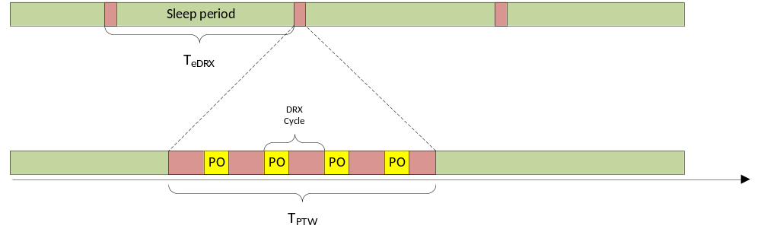
Extended DRX in Idle mode
The eDRX parameter values, i.e. timer values for T_{eDRX} and T_{PTW} are negotiated and configured during ATTACH and RAU procedure. During sleep period, the AirPrime HL7800 module may enter low power mode state to reduce its power consumption.
T_{eDRX} can be set from 5,12 seconds up to 2621.44 seconds (~44 minutes) in Cat M1 and from 20,48 seconds up to 10485,76 seconds (~175 minutes) in NB1. Requested value may be configured by the customer through +CEDRXS command. Negotiated eDRX values (T_{eDRX} and T_{PTW}) may be read through +CEDRXRDP command.

+CEDRXS AT command
See Document [R-1] for detailed AT command description
Syntax
AT+CEDRXS=[<mode>,[,<AcT-type>[,<Requested_eDRX_value>]]]
Description
The set command controls the setting of the UEs eDRX parameters. The command controls whether the UE wants to apply eDRX or not, as well as the requested eDRX value for each specified type of access technology.
Defined values
<mode>: integer type, indicates to disable or enable the use of eDRX in the UE.
0 Disable the use of eDRX
1 Enable the use of eDRX
2 Enable the use of eDRX and enable the unsolicited result code
+CEDRXP: <AcT-type>[,<Requested_eDRX_value>[,<NW-provided_eDRX_value>[,<Paging_time_window>]]]
3 Disable the use of eDRX and discard all parameters for eDRX or, if available, reset to the manufacturer specific default values.
<AcT-type>: integer type, indicates the type of access technology. This AT-command is used to specify the relationship between the type of access technology and the requested eDRX value.
4 E-UTRAN (WB-S1 mode) = Cat-M1
5 E-UTRAN (NB-S1 mode) = NB1

<Requested_eDRX_value>: string type; half a byte in a 4-bit format. eDRX value is coded as described below:
bit
4 | 3 | 2 | 1 | T_{eDRX} | Comment
0 | 0 | 0 | 0 | 5,12 seconds | For Cat-M1 only
0 | 0 | 0 | 1 | 10,24 seconds | For Cat-M1 only
0 | 0 | 1 | 0 | 20,48 seconds
0 | 0 | 1 | 1 | 40,96 seconds
0 | 1 | 0 | 0 | 61,44 seconds | For Cat-M1 only
0 | 1 | 0 | 1 | 81,92 seconds
0 | 1 | 1 | 0 | 102,4 seconds | For Cat-M1 only
0 | 1 | 1 | 1 | 122,88 seconds | For Cat-M1 only
1 | 0 | 0 | 0 | 143,36 seconds | For Cat-M1 only
1 | 0 | 0 | 1 | 163,84 seconds
1 | 0 | 1 | 0 | 327,68 seconds
1 | 0 | 1 | 1 | 655,36 seconds
1 | 1 | 0 | 0 | 1310,72 seconds
1 | 1 | 0 | 1 | 2621,44 seconds
1 | 1 | 1 | 0 | 5242,88 seconds | For NB1 only
1 | 1 | 1 | 1 | 10485,76 seconds | For NB1 only

+CEDRXP AT command
See Document [R-1] for detailed AT command description
Syntax
AT+CEDRXP
+CEDRXRDP: <AcT-type>[,<Requested_eDRX_value>[,<NW-provided_eDRX_value>[,<Paging_time_window>]]]
OK
Description
The execution command returns <AcT-type> and <Requested_eDRX_value>, <NW-provided_eDRX_value> and <Paging_time_window> if eDRX is used for the cell that the MS is currently registered to.
Defined values
<Act-Type> and <Requested_eDRX_value> same as +CEDRXS command
<Paging_time_window>
The PTW value is derived as follows for <Act-Type> = 4 (Cat-M1):

bit
4 | 3 | 2 | 1 | Paging Time Window length
0 | 0 | 0 | 0 | 1,28 seconds
0 | 0 | 0 | 1 | 2,56 seconds
0 | 0 | 1 | 0 | 3,84 seconds
0 | 0 | 1 | 1 | 5,12 seconds
0 | 1 | 0 | 0 | 6,4 seconds
0 | 1 | 0 | 1 | 7,68 seconds
0 | 1 | 1 | 0 | 8,96 seconds
0 | 1 | 1 | 1 | 10,24 seconds
1 | 0 | 0 | 0 | 11,52 seconds
1 | 0 | 0 | 1 | 12,8 seconds
1 | 0 | 1 | 0 | 14,08 seconds
1 | 0 | 1 | 1 | 15,36 seconds
1 | 1 | 0 | 0 | 16,64 seconds
1 | 1 | 0 | 1 | 17,92 seconds
1 | 1 | 1 | 0 | 19,20 seconds
1 | 1 | 1 | 1 | 20,48 seconds
The PTW value is derived as follows for <Act-Type> = 5 (NB1)::

bit
8 | 7 | 6 | 5 | Paging Time Window length
0 | 0 | 0 | 0 | 2,56 seconds
0 | 0 | 0 | 1 | 5,12 seconds
0 | 0 | 1 | 0 | 7,68 seconds
0 | 0 | 1 | 1 | 10,24 seconds
0 | 1 | 0 | 0 | 12,8 seconds
0 | 1 | 0 | 1 | 15,36 seconds
0 | 1 | 1 | 0 | 17,92 seconds
0 | 1 | 1 | 1 | 20,48 seconds
1 | 0 | 0 | 0 | 23,04 seconds
1 | 0 | 0 | 1 | 25,6 seconds
1 | 0 | 1 | 0 | 28,16 seconds
1 | 0 | 1 | 1 | 30,72 seconds
1 | 1 | 0 | 0 | 33,28 seconds
1 | 1 | 0 | 1 | 35,84 seconds
1 | 1 | 1 | 0 | 38,4 seconds
1 | 1 | 1 | 1 | 40,96 seconds

Example
To request an eDRX cycle of 81,92s, which is the more optimized value for the AirPrime HL7800 module (1):
AT+CEDRXS=1,4,5
OK
AT+CEDRXP
+CEDRXRDP: 4,5,5,0
OK
In this example, the network accepted the 81,92s edRX cycle and provided a PTW of 1,28 seconds

Note: (1): While 3GPP specifications allow eDRX sleep times of up to 44 minutes, Sierra has been able to achieve significant eDRX current savings by enforcing a 81,92s cycle time which also allows much lower latency. The clock drift associated with sleep times >> 81,92s significantly increases the time and current consumption to resynchronize with the network upon eDRX wake. For this reason any current savings from cycle times >> 81,92s are negligible.

AirPrime HL7800 Low Power modes

System description
The figure below presents an overview of the AirPrime HL7800 module’s internal architecture and the different power domains.
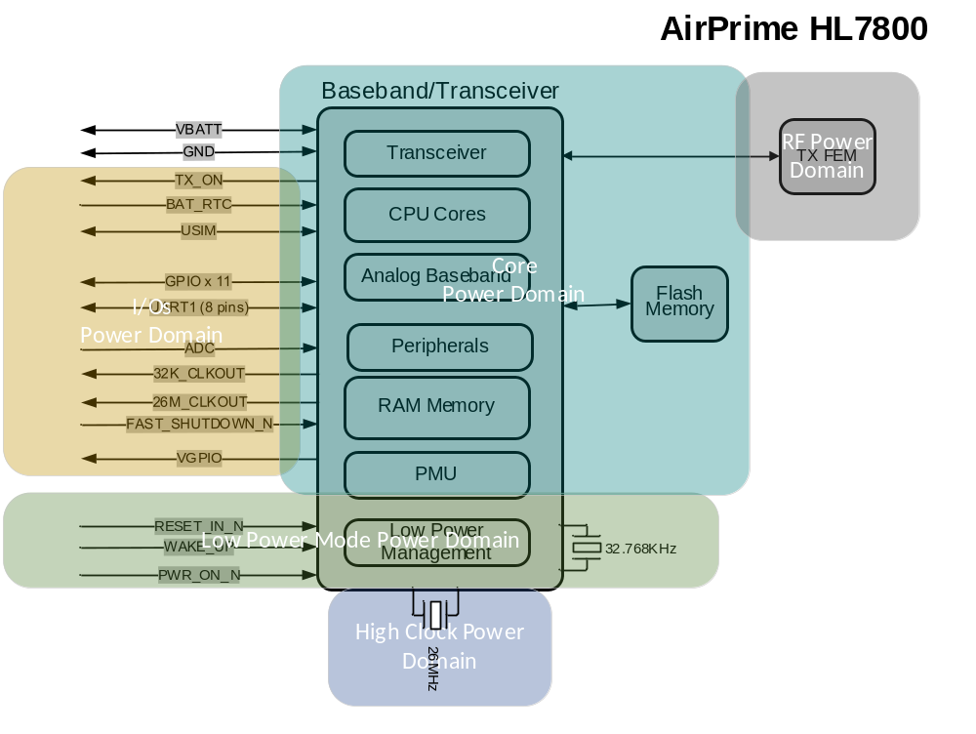
AirPrime HL7800 Power Domains

The AirPrime HL7800 module is composed of multiple power domains:
- Low Power Mode (LPM) Power domain: it corresponds to the Always ON domain and comprises the RTC, the 32KHz clock, a RAM retention memory and some I/Os:
  - RESET_IN_N to reset the module
  - WAKE_UP to wake-up the module from low power modes
  - PWR_ON_N to manage the Power ON of the module (will be available in a future release)
- I/O Power domain: This power domain is used to maintain I/Os in some low power modes and to allow module wake-up from UART DTR signal. When this domain is ON, VGPIO output is available.
- Core Power Domain: This power domain corresponds to the main system and implies that LPM and I/O Power domains are ON.
- High Clock Power Domain: This power domain corresponds to the main system clock and implies Core Power domain is ON.
- RF Power Domain: This power domain is ON during RX/TX activity.
For more details on the Hardware architecture of the AirPrime HL7800 module, please refer to document [R-2].

AirPrime HL7800 power modes
3 low power modes are supported on the AirPrime HL7800 module. This mode can be configured through the AT+KSLEEP command (See document [R-1] for details).
Low power modes may be permanently disable through +KSLEEP AT command or enable/disable through UART DTR signal. When low power mode is disable, AirPrime module will stay in Running mode.

+KSLEEP AT command
See Document [R-1] for detailed AT command description

Running mode
All power domains but RF power domain are ON. RF power domain is only ON during 4G Rx/Tx activity.

Sleep mode
In Sleep mode, all power domains, except High Clock and RF power domains, are ON.
This mode is entered by the AirPrime HL7800 module if the following conditions are met:
- Sleep mode is allowed (KSLEEP and UART DTR),
- Modem is in DRX or in extended DRX or in OFF (AT+CFUN=0) or PSM dormant or in no network coverage mode,
- WAKE-UP Pin is set to High.
- RESET_IN_N pin is set to High
- No activity on the UART in the last 5 seconds.
The available wake up source for this low power modes are:
- WAKE_UP signal
- UART DTR signal.
- Modem events such as SMS or IP data reception.
- Internal processing need such as internal timer expiration, interrupts, …
Note: In this mode, UART data reception doesn’t trigger a module wake-up, but module may be responsive to AT command sent on the UART if module is awake due to internal processing.

Lite Hibernate mode
In Lite Hibernate mode, only I/O and LPM power domains are ON and only modem state and data are retained in the LPM RAM. All other volatile data (application data) are lost: for instance, UDP/TCP socket connections, PPP connection, unsolicited command configuration, … When the AirPrime HL7800 module exits from this mode, the Host processor shall act as after a module reset.
This mode is entered by the AirPrime HL7800 module if the following conditions are met:
- Lite Hibernate is allowed (KSLEEP and UART DTR),
- Modem is in extended DRX, OFF or PSM dormant or in no network coverage mode.
- WAKE-UP Pin is set to High.
- RESET_IN_N pin is set to High
- No activity on the UART in the last 5 seconds.
In this mode, the AirPrime HL7800 module can wake-up from:
- WAKE_UP signal
- UART DTR signal
- T3412 timer expiration
- SMS or IP data reception if eDRX mode is configured
- Modem state change

Hibernate mode
In Hibernate mode, only LPM power domains is ON and only modem state and data are retained in the LPM RAM. As for Lite Hibernate, all other volatile data (application data) are lost: for instance, UDP/TCP socket connections, PPP connection, unsolicited command configuration, … When the AirPrime HL7800 module exits from this mode, the Host processor shall act as after a module reset.
This mode is entered by the AirPrime HL7800 module if the following conditions are met:
- Hibernate Low Power mode is allowed (KSLEEP and UART DTR),
- Modem is in OFF or PSM dormant or in no network coverage mode.
- Modem is extended DRX mode and UICC card can be deactivated (1).
- WAKE-UP Pin is set to High.
- RESET_IN_N pin is set to High
In this mode, the AirPrime HL7800 module can wake-up from:
- WAKE_UP signal
- T3412 timer expiration
- SMS or IP data reception if eDRX mode is configured
- Modem state change
Note (1): UICC DEACTIVATION mechanism is a release 13 feature: description in ETSI TS 131 102 V13.4.0 clause 5.1.10 and 5.1 11
  - in PSM, UICC deactivation can be done if PIN code is disabled
  - in eDRX, UICC deactivation can be done if PIN code is disabled AND deactivation of UICC is authorized in EFAD.
If UICC deactivation is not allowed, AirPrime HL78000 module selects automatically Lite Hibernate mode.

Low power mode operation
The customer can configure the lowest power mode that may be entered by the AirPrime HL7800 module. The AirPrime HL7800 selects the best power mode according to the KSLEEP configuration and the modem state according to the below simplified automaton.
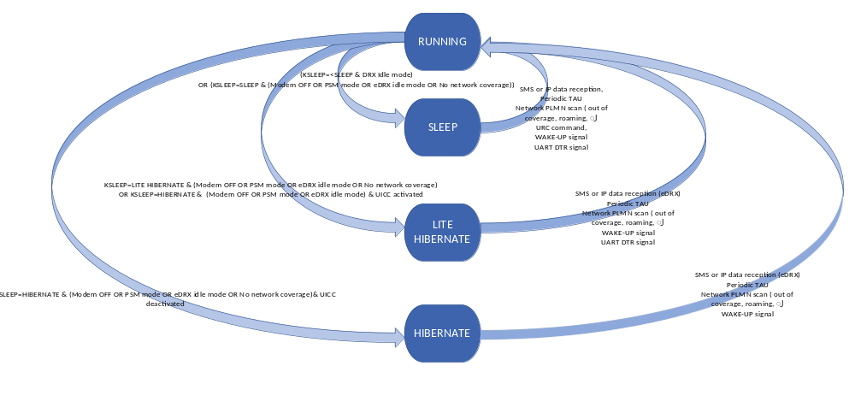
AirPrime HL7800 Power Modes Automaton (simplified view)

The following table sums up the different modes:
AT+KSLEEP | Possible Modem states | IOs State | Hardware Wake-up Signal source | Application Data
SLEEP | OFF, DRX, eDRX, PSM, No service | Retained | UART_DTR  WAKE-UP | Retained
LITE_HIBERNATE | OFF, eDRX, PSM, No service | Retained | UART_DTR  WAKE-UP | Not retained
HIBERNATE | OFF, eDRX, PSM, No service | Not retained | WAKE-UP | Not retained
AirPrime HL7800 Power Modes table

Low Power mode use cases

PSM use cases
The recommended Low Power state while the AirPrime HL7800 module is in PSM mode is the HIBERNATE mode. When configured in PSM mode, the module enters the lowest power consumption mode once the Active Timer expires and wakes up periodically (based on the extended TAU timer) to perform a Tracking Area Update.
In this state, the IOs are not retained and AirPrime HL7800 module can be wake-up only from WAKE_UP pin.

Entering in PSM mode
CPSMS and KSLEEP AT commands shall be used to configure the AirPrime HL7800 module in PSM mode with HIBERNATE low power mode.
AT command sequence
at at+cpsms=1,,,"00100001","00000101" PSM request with extended TAU period of 1 hour and Active timer of 10 seconds.
AT+KSLEEP=0,2 Hibernate mode configuration with DTR management
Sequence diagram
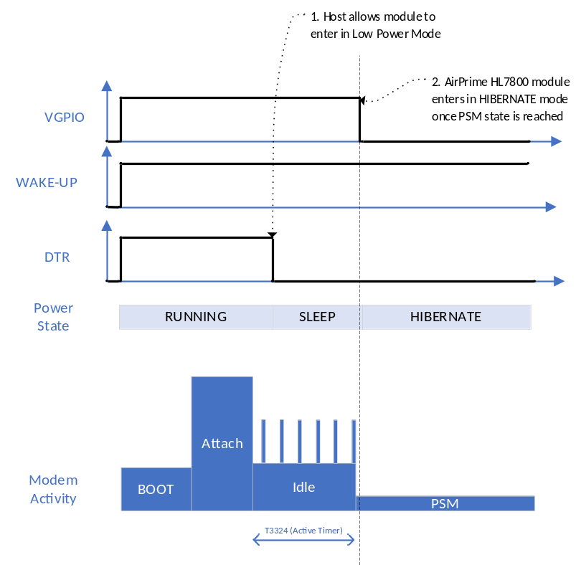
PSM mode – basic use case

TAU procedure with SMS reception
If required by the host, AirPrime HL7800 module can notify reception of SMS through UART RI signal. Such a notification can be enable through +KRIC AT command. This will allow host to be wake-up when a SMS is received after the TAU procedure for instance.
AT commands configuration
at at+cpsms=1,,,"00100001","00000101" PSM request with extended TAU period of 1 hour and Active timer of 10 seconds.
AT+KSLEEP=0,2 Hibernate mode configuration with DTR management
AT+KRIC= 0X02,0,1 RI signal to notify host on SMS reception
Sequence diagram
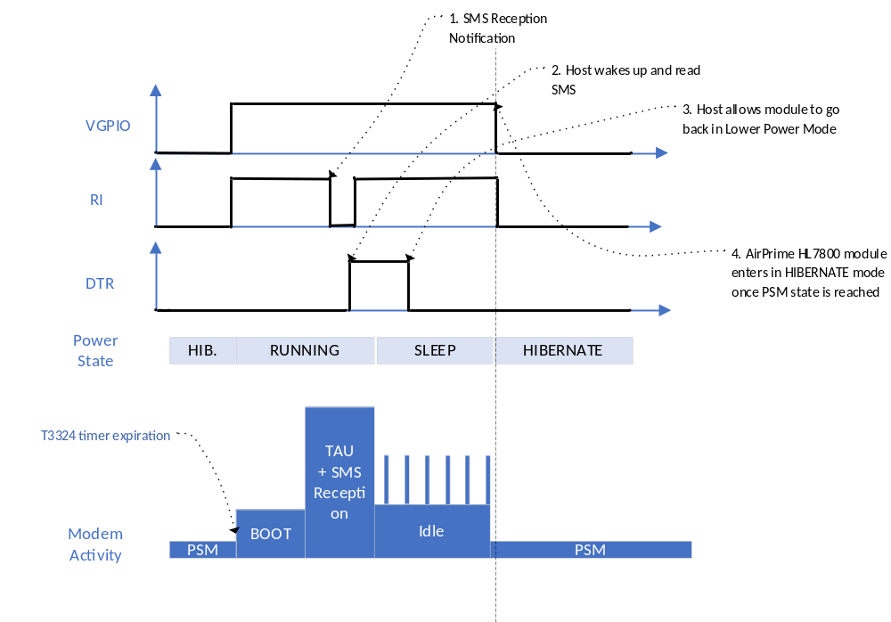
PSM mode – SMS reception after TAU procedure

Data transmission initiated by the Host
While AirPrime HL7800 module is in PSM mode and HIBERNATE low power mode, host may want to send data over the network. Before sending data, host shall first wake-up the module thanks to WAKE-UP signal. Once the UART_CTS signal is Active, host shall reopen TCP/UDP socket or reinitiate PPP connection over UART. As PDN/PDP context is saved in PSM mode, these procedures are speed up.
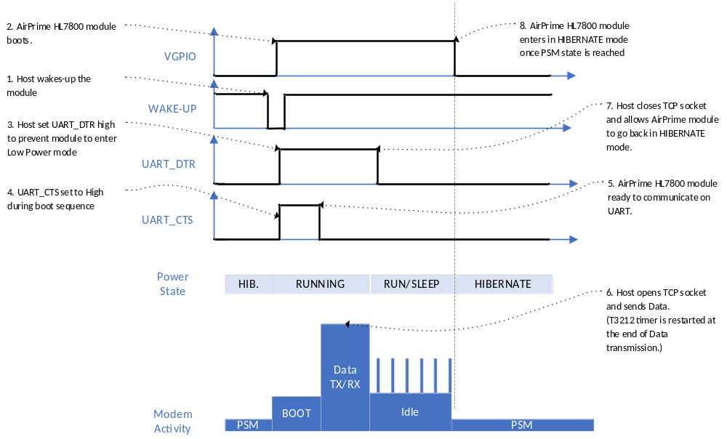
PSM mode – Mobile Originated Data Transmission

eDRX use cases
To achieve the best power consumption saving while the AirPrime HL7800 module is in eDRX mode, the recommended Low Power state is the HIBERNATE mode. When configured in eDRX mode, the module enters the lowest power consumption mode during eDRX sleep period. In particular, this mode depends on the UICC configuration as explained in previous paragraph:
- If the UICC doesn’t allow UICC deactivation in eDRX mode, the AirPrime HL7800 enters in LITE HIBERNATE mode during eDRX sleep period.
- If the UICC allows UICC deactivation in eDRX mode, the AirPrime HL7800 enters in HIBERNATE mode during eDRX sleep period.
AirPrime HL7800 module wakes-up periodically to listen to the paging as described in the first chapter. This wake-up is a partial wake-up meaning that only the modem subsystem of the module will be awake. Once the new eDRX sleep period is reached, the AirPrime HL7800 module goes back in HIBERNATE mode

Entering in eDRX mode
CEDRXS and KSLEEP AT commands shall be used to configure the AirPrime HL7800 module in eDRX mode with HIBERNATE low power mode.
AT command sequence
AT+CEDRXS=1 eDRX enable
AT+KSLEEP=0,2 Hibernate mode configuration with DTR management
Sequence diagram
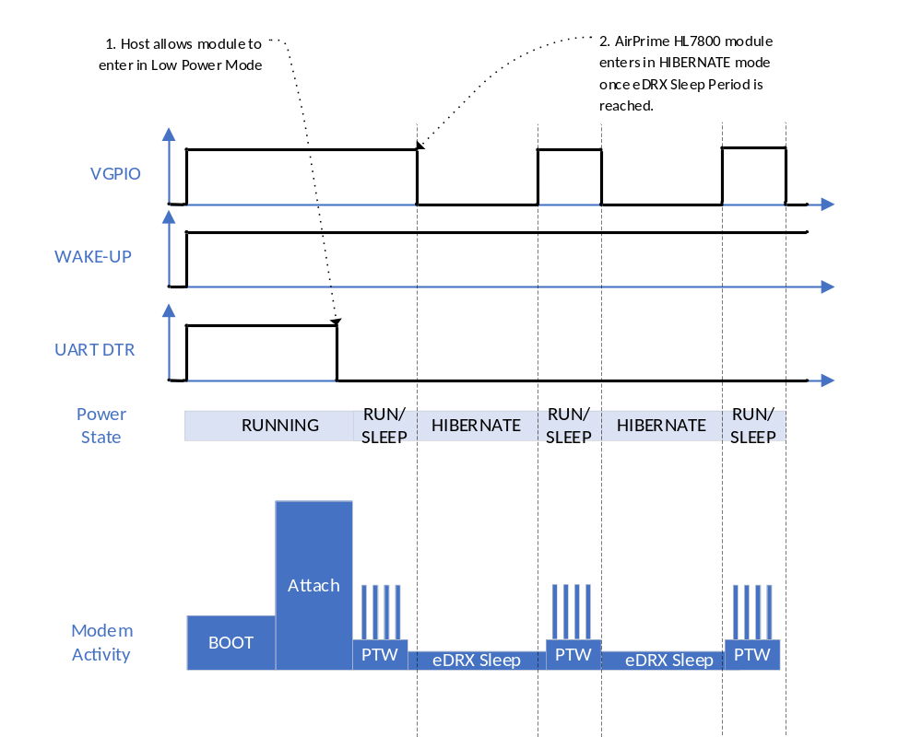
eDRX mode – initial configuration

SMS Reception in eDRX mode
To be continued

